CHAPTER ONE
INTRODUCTION
1.1 Background of the Study
Education plays a crucial role in national development and human capacity building. In tertiary institutions, effective teaching and learning require proper monitoring mechanisms, one of which is student attendance. Attendance is an important indicator of students’ commitment to academic activities and is often used in continuous assessment and examination eligibility.
Despite its importance, many institutions still rely on manual attendance methods such as paper registers and roll calls. These methods are time-consuming, especially in large classes, and reduce valuable lecture time. They are also prone to errors, loss of records, and proxy attendance, where students sign in for absent colleagues. As student populations continue to increase, manual attendance systems have become inefficient and unreliable.
Advancements in information and communication technology (ICT) have made it possible to automate attendance management. Biometric technologies provide accurate and secure means of identification, with face recognition gaining attention due to its contactless and non-intrusive nature. Face recognition uses unique facial features to identify individuals and has been widely applied in security and authentication systems.
Applying face recognition technology to classroom attendance offers a fast, accurate, and reliable solution. Attendance can be recorded automatically in real time without disrupting lectures, while eliminating impersonation. This project therefore focuses on the design and implementation of a face recognition-based classroom attendance system to improve efficiency and accuracy in attendance management.

1.2 Statement of the Problem
Despite the importance of student attendance in tertiary institutions, several challenges exist in the current attendance management system. These problems include:
- Time Consumption: Manual attendance taking consumes valuable lecture time, especially in large classes.
- Proxy Attendance: Students often mark attendance on behalf of absent colleagues, making records unreliable.
- Inaccuracy of Records: Manual methods are prone to errors, loss of attendance sheets, and incorrect entries.
- Difficulty in Managing Large Classes: Lecturers find it difficult to effectively monitor attendance in large lecture halls.
- Lack of Secure Record Keeping: Paper-based attendance systems lack secure storage and centralized access to attendance data.
1.3 Aim and Objectives of the Study
The aim of this project is to design and implement a student attendance system in the classroom using face recognition techniques.
The objectives of the study are as follows:
- Develop an automated attendance system that reduces the time spent on manual attendance taking.
- Design a face recognition mechanism that eliminates proxy attendance and impersonation.
- Ensure reliable recording of student attendance.
- Create a system that effectively manages attendance in large classroom settings.
- Provide secure storage and easy retrieval of attendance records for academic and administrative use.
1.4 Significance of the Study
This study is significant because it:
- Improves attendance management: The face recognition-based attendance system can reduce errors, proxy attendance, and time consumption, making it a more efficient and reliable solution.

- Enhances academic administration: Accurate attendance records can inform academic decisions, improve student engagement, and support institutional planning.

- Contributes to technological innovation: The study applies face recognition technology to a specific problem, demonstrating its potential for improving educational processes.

- Supports large class management: The system can effectively manage attendance in large lecture halls, reducing the workload for lecturers and improving student experience.
1.5. Scope and Limitation of the Study
This study focuses on:
- Designing and implementing a face recognition-based attendance system: The system will use facial features to identify students and record attendance automatically.

- Tertiary institutions: The study will be conducted in a university or college setting, with a focus on improving attendance management in classrooms.

- Automated attendance recording: The system will eliminate manual attendance taking, reducing errors and proxy attendance.
- Technical limitations: The system's accuracy may be affected by factors like lighting, facial expressions, or image quality.
- Data quality and security: The study will require access to student facial data, which raises concerns about data protection and security.
- Scalability: The system's effectiveness in very large or diverse student populations may require further investigation.
- User acceptance: The study may face challenges in terms of user acceptance and adoption of the new technology.

1.7. Definitions of Terms
- Attendance Management System: A system used to record and manage student attendance in educational institutions.
- Face Recognition Technology: A biometric technology that uses facial features to identify individuals.
- Automated Attendance System: A system that uses technology to automatically record student attendance without manual intervention.
- Biometric Identification: A method of identifying individuals based on unique physical characteristics, such as facial features or fingerprints.
- Proxy Attendance: The practice of one student marking attendance on behalf of another student who is absent.
- Classroom Attendance: The presence of students in a classroom during scheduled lecture hours.
- Tertiary Institution: A post-secondary educational institution, such as a university or college.
- Manual Attendance System: A system that relies on manual recording of student attendance using paper registers or roll calls.
- Facial Features: Unique characteristics of a person's face, such as the shape of the eyes, nose, and mouth, used for identification purposes.
- Image Processing: The use of algorithms and techniques to analyze and extract information from digital images.
- Machine Learning: A type of artificial intelligence that enables systems to learn from data and improve their performance over time.

CHAPTER TWO

LITERATURE REVIEW

2.1 Conceptual Review
This section explains the key concepts relevant to the design and implementation of a face recognition-based attendance system.

2.1.1 Database Management System (DBMS)
A Database Management System (DBMS) is software used to create, store, and manage data in an organized manner. It allows users to easily retrieve and update information while ensuring data security and integrity.
In attendance systems, DBMS is used to store student details, facial data, and attendance records. It also supports efficient data retrieval and prevents data loss (Elmasri&Navathe, 2016).

2.1.2 Attendance Management System
An attendance management system is used to monitor and record students’ presence during lectures. Manual methods such as paper registers are commonly used but are inefficient and prone to errors.
Automated systems improve attendance management by:
- Saving time
- Increasing accuracy
- Preventing proxy attendance
- Providing real-time records
These systems are particularly useful in large classrooms (Bhardwaj&Aggarwal, 2019).

2.1.3 Biometric Identification
Biometric identification involves recognizing individuals using unique physical characteristics such as fingerprints or facial features. It provides a higher level of security compared to traditional methods.
Biometric systems reduce impersonation and ensure that attendance records are accurate and reliable (Jain et al., 2011).

2.1.4 Face Recognition Technology
Face recognition is a biometric method that identifies individuals based on facial features. It involves detecting a face, extracting features, and matching them with stored data.
It is widely used because it is:
- Fast
- Contactless
- Convenient
However, factors such as lighting and facial expressions can affect its accuracy (Zhao et al., 2003).

2.1.5 Image Processing
Image processing refers to techniques used to analyze and enhance images. In face recognition systems, it helps in detecting faces and extracting important features.
Common techniques include filtering, segmentation, and feature extraction (Gonzalez & Woods, 2018).

2.1.6 Machine Learning
Machine learning enables systems to learn from data and improve their performance over time. It is used in face recognition to enhance accuracy and adapt to variations in facial features.
This makes the system more reliable in real-life conditions (Mitchell, 1997).

2.2 Theoretical Framework
This study is guided by the following theories:

2.2.1 Relational Database Theory
This theory organizes data into tables, making it easy to store and retrieve information. It is used in this project to manage student and attendance data (Codd, 1970).

2.2.2 Client-Server Architecture
This model divides the system into a client (user interface) and a server (data processing unit). It ensures efficient communication and centralized data storage (Tanenbaum& Van Steen, 2007).

2.2.3 Pattern Recognition Theory
Pattern recognition involves identifying patterns in data. In face recognition systems, it helps in matching facial features accurately (Bishop, 2006).

2.2.4 Artificial Neural Networks (ANN)
ANNs are used to improve recognition accuracy by learning patterns from facial data. They enhance the system’s ability to identify individuals correctly (Haykin, 2009).

2.3 Review of Related Works
Several studies have been conducted on automated attendance systems.
Bhardwaj and Aggarwal (2019) developed an RFID-based attendance system. While it improved speed, it allowed proxy attendance since cards could be shared.
Arulogun et al. (2013) introduced a fingerprint-based system which improved accuracy but required physical contact and was slow in large classes.
Joseph et al. (2015) developed a face recognition system using PCA. It reduced impersonation but was affected by lighting conditions.
Wagh et al. (2015) designed a face recognition system with high accuracy but required high computational resources.
Rekha and Ramaprasad (2017) improved face recognition using machine learning, achieving better accuracy but requiring more processing power.

Summary of Findings
- Automated systems are more efficient than manual methods
- Biometric systems reduce impersonation
- Face recognition is more convenient
- Environmental factors affect system performance

2.4 Gap in Literature
Despite improvements, some challenges remain:
- Poor performance under low lighting conditions
- Difficulty managing large classrooms
- High implementation cost
- Limited focus on user-friendly design
- Data security concerns

CHAPTER THREE

METHODOLOGY AND SYSTEM ANALYSIS

3.1 METHODOLOGY ADOPTED
The methodology adopted for this project is the System Development Life Cycle (SDLC) using the Waterfall Model. This approach is chosen because it provides a structured and sequential process suitable for system design and implementation. The systematic progression of the project through its various stages—from requirement analysis to maintenance—is illustrated in Figure 3.1 below.
The stages involved include:
- Requirement Analysis
- System Design
- Implementation
- Testing
- Deployment
- Maintenance

Justification for Using Waterfall Model
- It ensures proper documentation at each stage
- It is easy to understand and implement
- It allows systematic development of the system
- Suitable for academic research projects

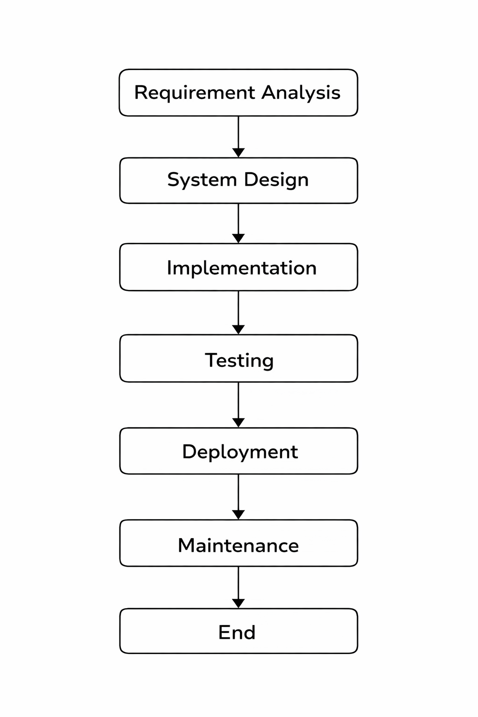

Figure 3.1: Methodology Flow Diagram (Waterfall Model)

3.2 SYSTEM ANALYSIS
System analysis involves studying the current system, identifying its problems, and proposing improvements. The interaction between the core hardware and software components of the proposed solution is depicted in the general system architecture shown in Figure 3.2.
In this project, the system analysis focuses on:
- Understanding the manual attendance system
- Identifying its limitations
- Designing an automated face recognition system

Key Components of the System
- Camera (Image Capture Device)
- Face Recognition Software
- Database System
- User Interface (Admin/Lecturer Panel)
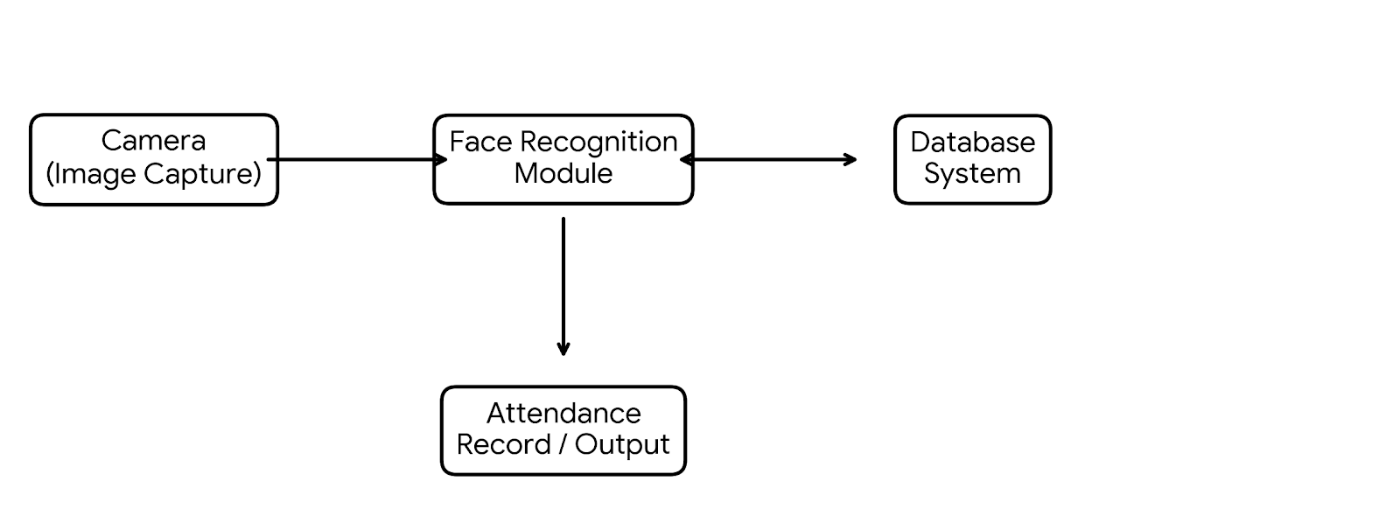

Figure 3.2: General System Architecture

3.3 ANALYSIS OF THE EXISTING SYSTEM

The existing system used in most institutions is the manual attendance system. The step-by-step procedure currently followed by lecturers and students is mapped out in the flowchart provided in Figure 3.3.

Process of Existing System
Lecturer → Calls Names / Pass Sheet → Students Respond / Sign → Record Stored Manually

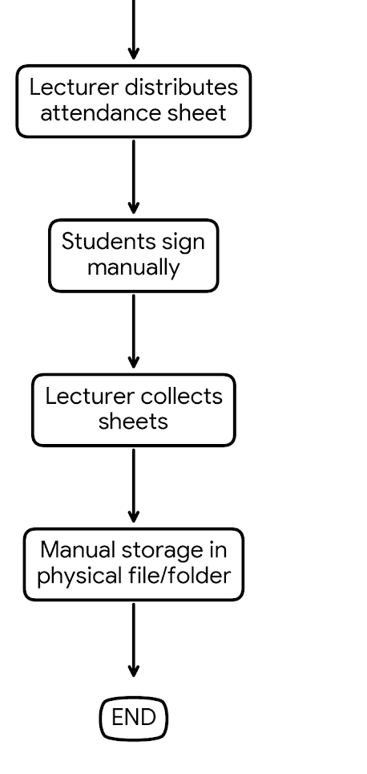

Figure 3.3: Flowchart of Existing System

3.4 WEAKNESS OF THE EXISTING SYSTEM
The manual attendance system has several limitations:

1. Time Consumption
- Takes a long time, especially in large classes
- Reduces lecture time

2. Proxy Attendance
- Students sign for absent colleagues
- Leads to inaccurate records

3. Human Errors
- Mistakes in marking attendance
- Loss or damage of attendance sheets

4. Poor Record Management
- Difficult to store and retrieve records
- No centralized database

5. Lack of Security
- No protection against manipulation
- Easy to falsify attendance

6. Inefficiency in Large Classes
- Difficult to manage hundreds of students
- Leads to delays and confusion

3.5 ANALYSIS OF THE PROPOSED SYSTEM
The proposed system is a Face Recognition-Based Attendance System that automates attendance using biometric technology. The automated logical sequence of image capture, feature extraction, and database matching is detailed in Figure 3.4.

How the System Works
- The camera captures student images
- The system detects faces
- Facial features are extracted
- Features are compared with stored database
- Attendance is recorded automatically
Flowchart of Proposed System
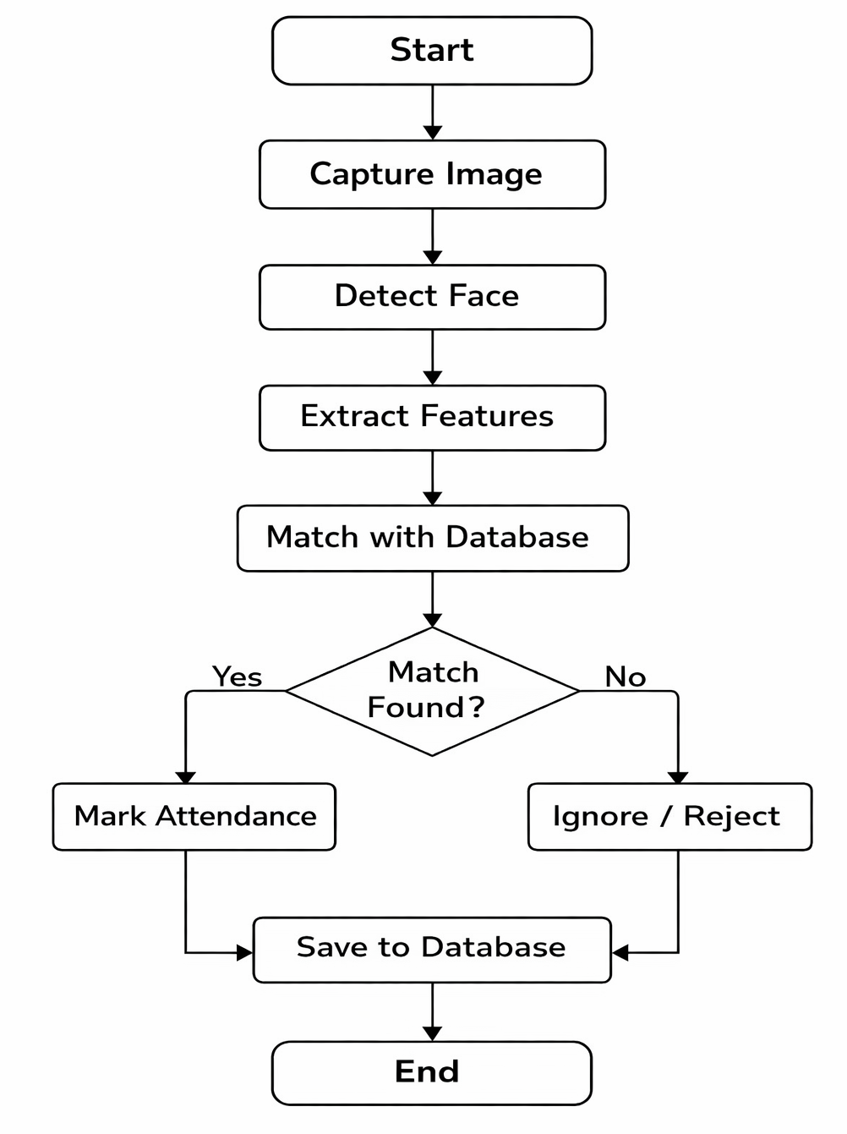

Figure 3.4: Flowchart of Proposed System

3.6 ADVANTAGES OF THE PROPOSED SYSTEM
The proposed system offers several benefits:

1. Time Efficiency
- Attendance is recorded instantly
- Saves lecture time

2. Elimination of Proxy Attendance
- Facial recognition ensures authenticity
- No impersonation

3. High Accuracy
- Reduces human errors
- Reliable records

4. Automated Record Keeping
- Data stored digitally
- Easy retrieval and management

5. Improved Security
- Biometric authentication
- Prevents data manipulation

6. Scalability
- Can handle large number of students
- Suitable for universities

7. Real-Time Processing
- Attendance recorded instantly
- Immediate updates

3.7 HIGH-LEVEL MODEL OF THE PROPOSED SYSTEM
The high-level model provides a conceptual overview of how the various components of the Face Recognition-Based Attendance System interact to achieve the goal of automated attendance tracking. This model serves as the blueprint for the system's architecture, illustrating the flow of data from the initial student interaction to the final administrative output. Figure 3.5 presents the High-Level System Diagram.
The model is divided into three primary layers:
- Input Layer: Comprising the camera system that captures student images in the classroom environment.
- Processing Layer: The core "Face Recognition System" which handles face detection, feature extraction, and database matching.
- Data & Output Layer: Includes the database for secure storage of student records and facial templates, as well as the reporting interface used by lecturers for attendance management.

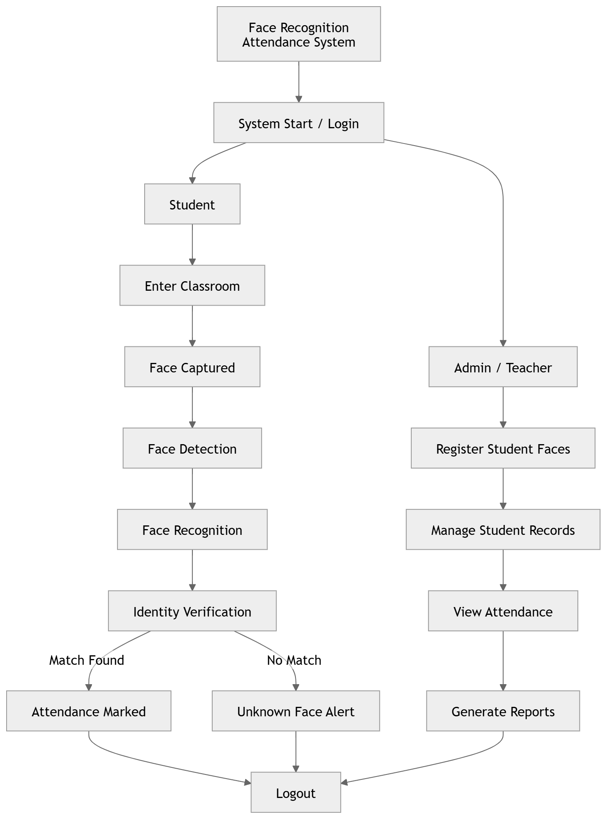

Figure 3.5: High-Level System Diagram

